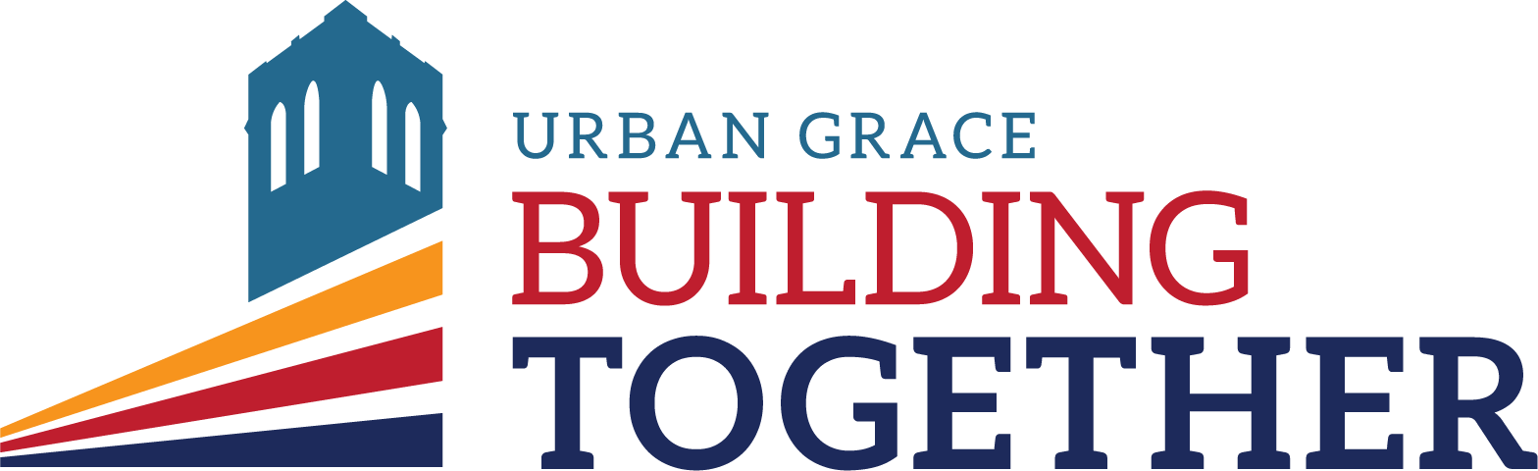

Urban Grace Church

Capital Campaign FAQ

Fall 2017

Q: What is our Building Together Campaign all about?
A: Our capital campaign is about investing in the future of Urban Grace and the community we serve.
- It is about building on our faith and the faith of people who came before us, to strengthen our facilities and ministry for years to come.
- It is about becoming a more welcoming environment for all you enter our doors.
- It is about growing as a congregation through a deeper understanding of stewardship,
community, and faith as disciples of Jesus Christ.

This fall we will be inspired, informed and involved in a variety of programs and fellowship events. In our worship service on Sunday, December 3rd, we will be invited to make a 3-year financial pledge, over and above our regular giving to our capital campaign fund. The gifts received from our Building Together Capital Campaign will help us accomplish a variety of renovation projects which will empower us to serve our current membership better, as well as our community now and into the future.

Q: What types of projects are we seeking to accomplish?
A: Funds from our capital campaign would be used to:
- upgrade some of our deteriorating plumbing,
- renovate the men’s bathroom,
- convert a portion of the women’s restroom into a non-gendered ADA accessible bathroom,
- bring hot water to our bathrooms
- prevent water damage by securing our sanctuary stained glass windows, replacing failing siding on the roof, and repairing mortar and masonry work,
- make needed upgrades in the Lower Temple kitchen,
- replace carpeting, some seating, and the sound system in the sanctuary
- restore the historic ceiling in the Lower Temple
The number of projects we are able to accomplish will depend on how much we are able to raise.

Q: How were these projects determined?
A: There was an extensive process to determine the projects that were needed and possible to address through the Building Together Capital Campaign. There were a variety of needs the Urban Grace Leadership were aware of, but we wanted to assure that we did not miss any vital projects. To this end we wrote and received several grants to fund two studies of the condition of our building. We hired Cardinal Architecture to assess the structural condition of the building; this study included an assessment from a structural engineer. We also hired Artifacts to produce a Historic Structures Report, which is a lengthy historical and architectural study of the building’s condition and historical significance. These studies, along with feedback gained during the congregational listening sessions in January 2017, gave us a wealth of information about the needs of our building. We received multiple bids for approximately 20 projects that had been identified to predict the costs of each project. As a part of the National Fund for Sacred Places grant, we additionally received a financial feasibility study to determine our fundraising capacity. With all of this information the Trustees, Council, and staff worked together to create a prioritized list of the projects that we hope to accomplish with the Building Together Capital Campaign.

Q: What are the cost projections for our campaign projects?
A: We have set three tiers, or three goals, that will enable to address the following projects,
- Foundation Goal- If we raise $225,000 we will be able to complete urgent repairs to the roof, masonry and stained glass windows, replace our aging plumbing, and renovate our bathrooms.
- Formation Goal- If we raise $350,000 we will be able to complete our Foundation Goal projects AND renovate the sanctuary, upgrade the Lower Temple kitchen, and replace carpeting on the first floor.
- Pinnacle Goal- If we raise $500,000 we will be able to complete our Formation Goal projects AND restore the Lower Temple ceiling, install new sanctuary lighting, and replace carpeting on the second floor.
NOTE: The actual costs of these projects are approximately 50% more than the goals we have listed, but if we are able to accomplish our goals the remaining cost will be reached through a grant from the National Fund for Sacred Places.

Q: I’ve heard that we have a grant opportunity with Partners for Sacred Places. What is this and how can it help support us in our efforts?
A: In November of 2016 it was announced that Urban Grace was one of fourteen churches in the U.S. that was chosen to be a part of the National Fund for Sacred Places. This program sought churches that are using their historic churches to make a significant impact on their community. Thus far we have received training, consulting, and support as we planned the Building Together Capital Campaign. In the coming months, we will receive a 2:1 matching grant of up to $250,000. This means if we raise $500,000 the National Fund for Sacred Places will award us a $250,000 grant. This also means that if you contribute $200/month for three years, the National Fund for Sacred Spaces will contribute an additional $3,600 to the Building Together Capital Campaign. The amount of this grant has not yet been determined because they are waiting to see how generous we are able to be. The ball is in our court!

Q: I see how we use our church building on Sundays, but what happens during the week? What do we really provide for our community?
A: Our historic church building truly is a gift to the community as we are home to Christian ministries, social service organizations, music teachers, artists, dance companies, and many others that use our building every week. According to Partners for Sacred Places Public Value Assessment, our building and the programs we run such as the community breakfast have an annual value of $318,094.54 to the downtown community. We use our programs to serve those in the community; in fact, 92.6% of the beneficiaries of our service programs are not members of Urban Grace.
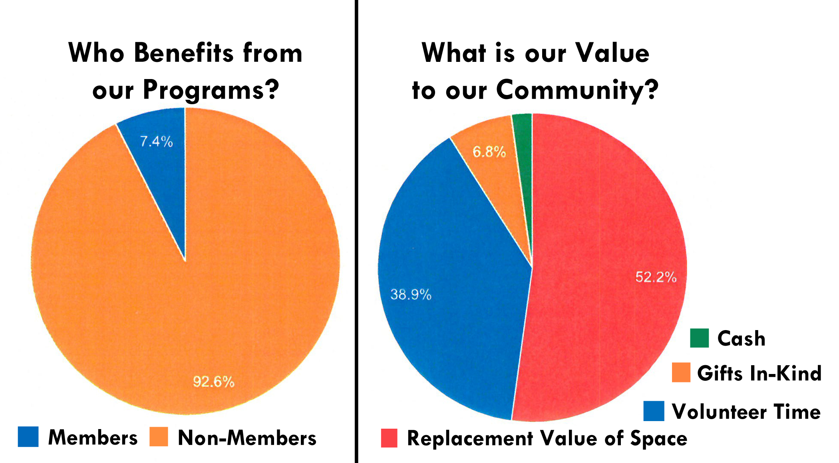

Q: When and how do I pay my pledge? What if my financial circumstances change?
A: Your three-year commitment to the Building Together campaign may be paid
incrementally in weekly, monthly, quarterly, or annual installments, or as a one-time gift. The gifting period will be December 2017 through December 2020. You, as the donor, will decide how best to complete your pledge. This chart shows the huge impact of regular gifts throughout our three-year campaign,

Monthly Gift | 3-Year Total | Monthly Gift | 3-Year Total
$2,000 | $ 72,000 | $ 240 | $ 8,640
$1,500 | $ 54,000 | $ 200 | $ 7,200
$1,200 | $ 42,200 | $ 180 | $ 6,480
$1,000 | $ 36,000 | $ 160 | $ 5,760
$ 800 | $ 28,800 | $ 140 | $ 5,040
$ 600 | $ 21,600 | $ 120 | $ 4,320
$ 500 | $ 18,000 | $ 100 | $ 3,600
$ 400 | $ 14,400 | $ 80 | $ 2,880
$ 360 | $ 12,960 | $ 60 | $ 2,160
$ 320 | $ 11,520 | $ 40 | $ 1,440
$ 280 | $ 10,080 | $ 20 | $ 720

Financial pledges are not legal obligations; however, it is anticipated that members will make their pledges in good faith, and will fulfill these fully. If circumstances change, you may revise your pledge by notifying the church.

Q: How can we be successful in achieving the goals of our campaign?
A: The financial goals for our campaign will represent a significant challenge for our church and yet will be within our capacity to fund. Churches similar to ours have raised $350K or more in projects like ours. We have the joyful opportunity to stretch ourselves to meet the current and future needs of Urban Grace.

The Urban Grace family has been blessed by God as we continue to grow in our giving. It is vital that we continue our commitment to support our current worship, work, and witness (our “regular” offerings). We also need to build a strong financial base for our capital ministry projects.

To meet the financial goals of our capital campaign, each of us will be asked to commit a generous and joyful gift above and beyond our regular giving. Each of us is encouraged to prayerfully consider—and celebrate!—the many blessings God has given us, and the capacity we have for giving and sharing generously. The choice is ours to freely commit that which has been entrusted to us. Seek God’s guidance as you consider these questions:

- To what extent does my giving truly reflect the value I have for this church?
- To what extent am I acting purposefully, intentionally, and faithfully in my giving?
- In what ways is my giving helping me grow in faith toward God, and in service to others?

Your support continues the tradition of generosity in our church, and will help Urban Grace
move forward in its mission and ministry.

Q: Why is our campaign – Building Together – so important?
A: Our campaign is about realizing God’s dream through our mission as God’s people to be a place of welcome for all.

It’s about honoring the commitment of everyone who has provided for our church over the years, and ensuring a bright future for our congregation, our community, and our ministries for years to come. Therefore, our campaign is about more than just finances.

Ours is the privilege and opportunity to carry forward the legacy of Urban Grace, celebrate the abundance God places in our lives, and carry forward God’s vision for us here.

